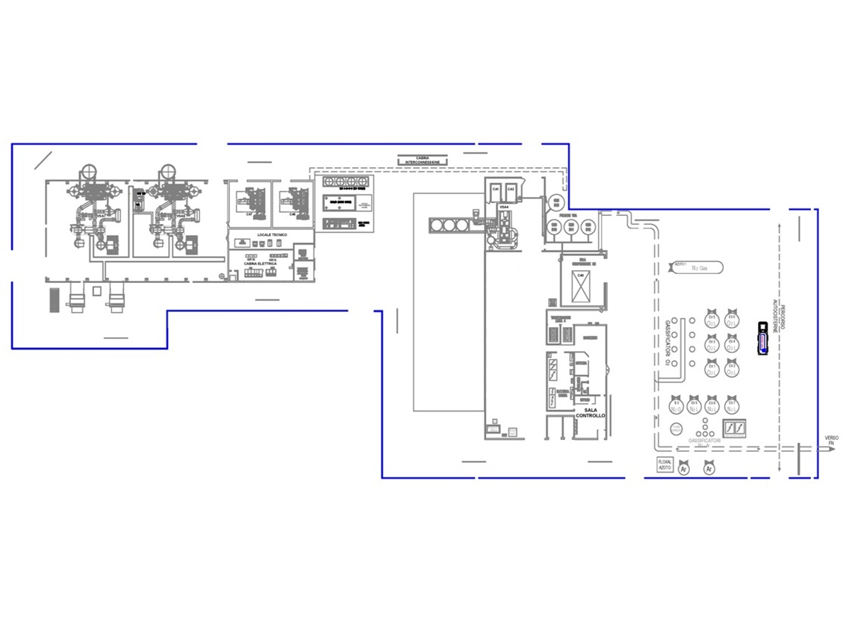
TUTTO L’IMPIANTO

- _______________________

- _______________________

- _______________________
ASSORBITORI LINEA 4
- ____________________
- ____________________
- ____________________
COMPRESSORE C46
- ___________________
- ____________________
- ____________________
COMPRESSORE C47
- ____________________
- ____________________
- ____________________
SKID VALVOLE LINEA 6
- ___________________
- ___________________
- ___________________
ASSORBITORI LINEA 6
- ___________________
- ___________________
- ___________________
SKID POMPE LINEA 4
- ______________________
- ______________________
- ______________________
COMPRESSORI C41 – C42
- ____________________
- ____________________
- _____________________
ASSORBITORI LINEA 7
- ____________________
- ____________________
- ____________________
SKID VALVOLE LINEA 7
- ____________________
- ____________________
- ____________________

SKID VALVOLE LINEA 7

- ____________________
- ____________________
- ____________________
CABINA ELETTRICA VSA 4
- ___________________
- ___________________
- ___________________
IMPIANTO RAFFED.H20
- ______________________
- ______________________
- ______________________
TRAFO 20/0,4KV LINEE 6-7
- ____________________
- ____________________
- ____________________
TRAFO 20/6KV LINEE 6-7
- ____________________
- ____________________
- ____________________
CABINA ELETTRICA VSA 6/7
- ____________________
- ____________________
- ____________________
IMPIANTO ARIA STRUMENTI
- ____________________
- ____________________
- ____________________
OFFICINA
- ______________________
- ______________________
- ______________________
DATA: _________ - N° ____

FIRMA

_____________________________
TRAFO 4ª LINEA
- ____________________
- ____________________
- ____________________
CABINA ELETTR.STOCC.
- ______________________
- ______________________
- ______________________
STOCCAGGIO OSSIGENO
- ____________________
- ____________________
- ____________________
STOCCAGGIO AZOTO
- ____________________
- ____________________
- ____________________
SERBATOIO AZOTO GAS
- ____________________
- ____________________
- ____________________
CAPACITA TAMPONE O2
- ____________________
- ____________________
- ____________________
VENTILAZIONE CAPANNONE CTA 1/2
- ____________________
- ____________________
- ____________________
SKID POMPE LINEA 6
- ____________________
- ____________________
- ____________________
SKID POMPE LINEA 7
- __________________
- __________________
- __________________
IMPIANTO OSMOSI
- ______________________
- ______________________
- ______________________

